MODEL VALIDATION

WASATCH FRONT TRAVEL DEMAND MODEL

VERSION 9.1.0

MAG / WFRC

October 31, 2024

Table of Contents

1 Trip Distribution 5

1.1 Trip Lengths 5

1.1.1 Average Trip Length Validation 5

1.1.2 Trip Length Frequency Validation 7

2 Mode Choice 10

2.1 Mode Share 10

2.1.1 Mode Share Calibration Results (Daily, All Purposes) 10

2.2 Transit Trips and Boardings 12

3 Highway Assignment 14

3.1 Volumes 14

3.2 Average Travel Time 19

List of Figures

Figure 1.1 Average Trip Length (Time) 5

Figure 1.2 Average Trip Length (Distance) 6

Figure 1.3 Trip Length Frequency - Beginning (HBW, HBShp, HBOth) 7

Figure 1.4 Trip Length Frequency (HBSch Primary, HBSch Secondary, NHBW) 8

Figure 1.5 Trip Length Frequency (NHBNW, IX) 9

Figure 2.1 Mode Share Calibration Results - Motorized / Non-Motorized (Daily, All Purposes) 10

Figure 2.2 Mode Share Calibration Results - Auto / Transit (Daily, All Purposes) 10

Figure 2.3 Mode Share Calibration Results - Drive Alone / Shared Ride (Daily, All Purposes) 11

Figure 2.4 Mode Share Calibration Results - Shared Ride 2 / Shared Ride 3 (Daily, All Purposes) 11

Figure 2.5 Mode Share Calibration Results - Transit Access Mode (Daily, All Purposes) 11

Figure 2.6 Mode Share Calibration Results - Transit Mode (Daily, All Purposes) 12

Figure 2.7 Trips and Boardings by Mode Surveyed - Model vs. Observed Comparison 13

Figure 3.1 Model vs Observed Volume and VMT Comparison (Region, All Vehicles) 15

Figure 3.2 Model vs Observed Volume and VMT Comparison (Region, Medium (MD) Trucks) 16

Figure 3.3 Model vs Observed Volume and VMT Comparison (Region, Heavy (HV) Trucks) 17

Figure 3.4 Segment-Level Model vs Observed Volume Comparison by Vehicle Type 18

Figure 3.5 Model vs Observed Times AM Period 20

Figure 3.6 Model vs Observed Times Midday Period 20

Figure 3.7 Model vs Observed Times PM Period 21

Figure 3.8 Model vs Observed Times Evening Period 21

List of Tables

# Trip Distribution

## Trip Lengths

The model used the 2012 Household Travel Survey to calibrate trip lengths for internal and external person trips. Trips were calibrated based on generalized cost trip length frequencies and validated to time and distance trip length frequencies and average trip lengths. The validation results are shown in Figure 1.1 through Figure 1.5. Trip lengths by time and distance met the validation targets and aligned closely with observed data.

No observed data was available for internal and external truck calibration. Truck trips were calibrated based on previous model estimation and validated relative to person work and other trip lengths.

### Average Trip Length Validation



Figure . Average Trip Length (Time)



Figure . Average Trip Length (Distance)

### Trip Length Frequency Validation

**HBOth – (Time) HBOth – (Distance)**

**HBW – (Time) HBW – (Distance)**

**HBShp – (Time) HBShp – (Distance)**

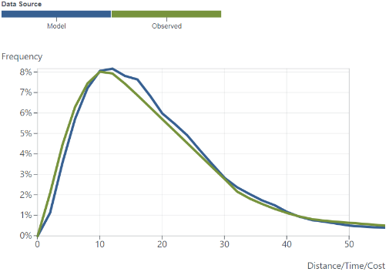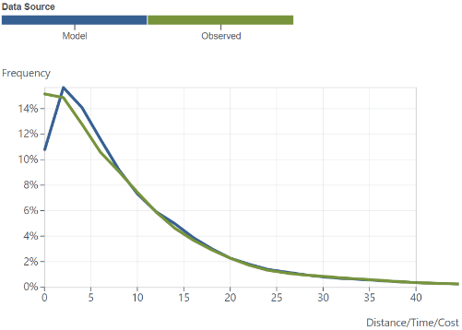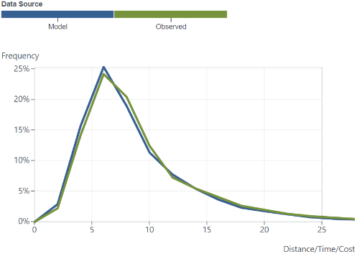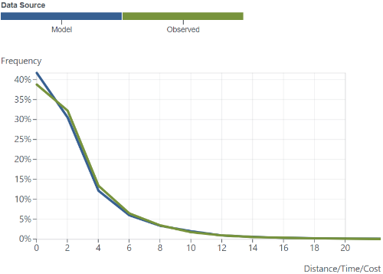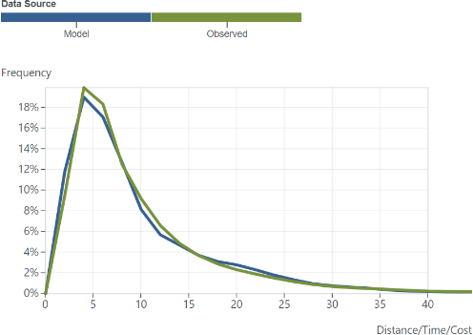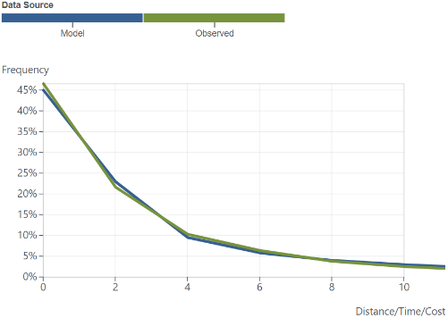

Figure . Trip Length Frequency - Beginning (HBW, HBShp, HBOth)

**NHBW – (Time) NHBW – (Distance)**

**HBSch Primary – (Time) HBSch Primary – (Distance)**

**HBSch Secondary – (Time) HBSch Secondary – (Distance)**

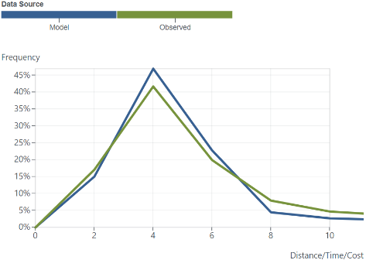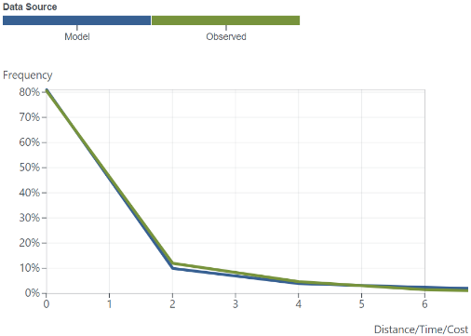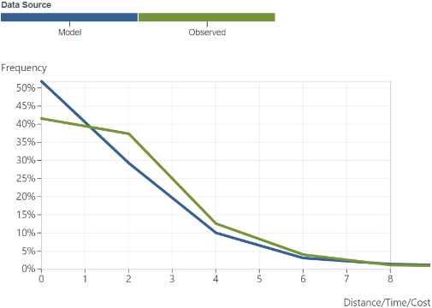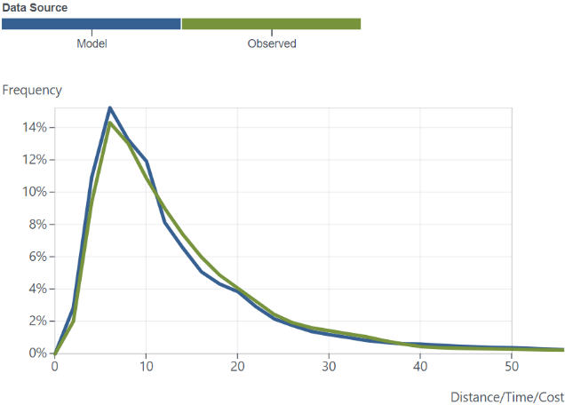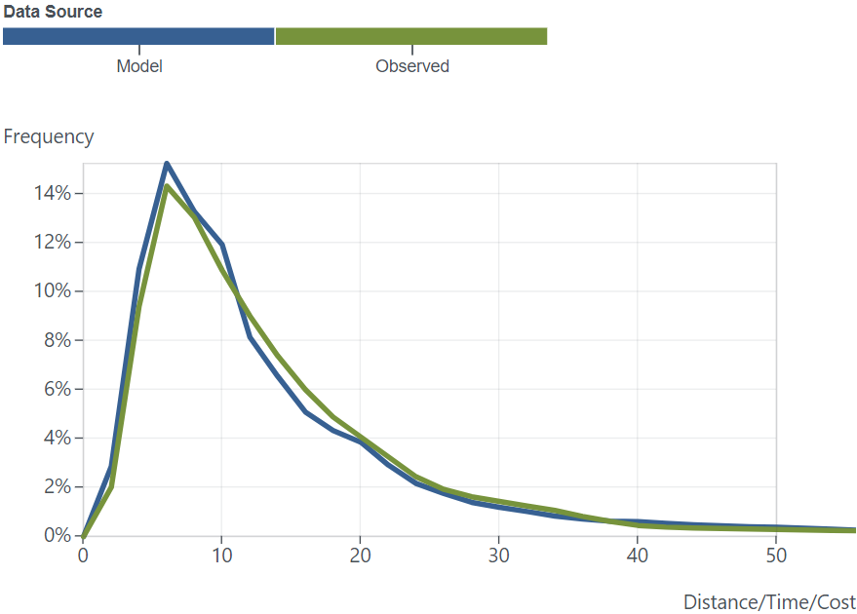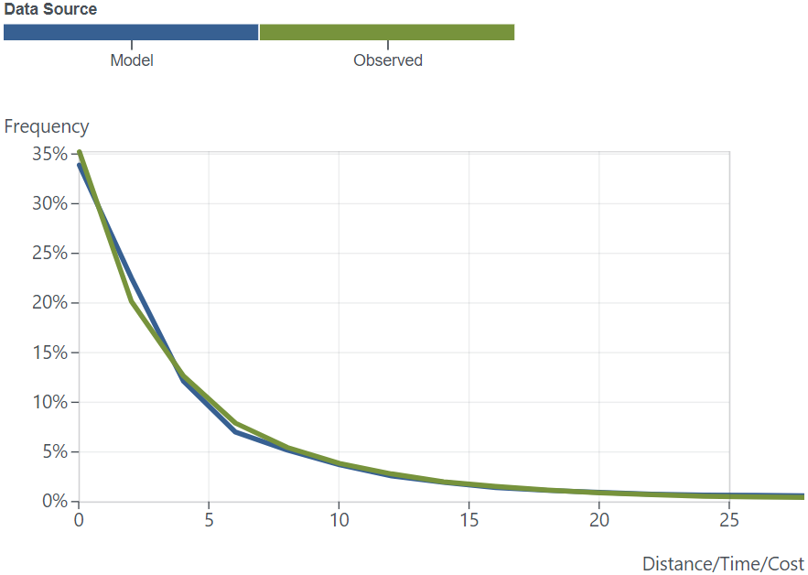

Figure . Trip Length Frequency (HBSch Primary, HBSch Secondary, NHBW)

**NHBNW – (Time) NHBNW – (Distance)**

**IX – (TIME) IX – (Distance)**

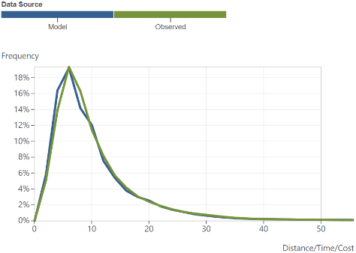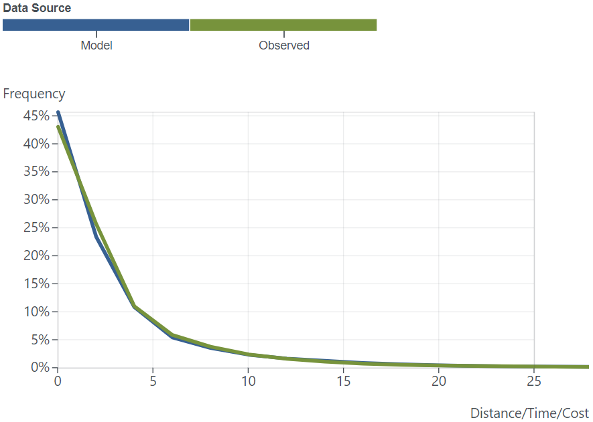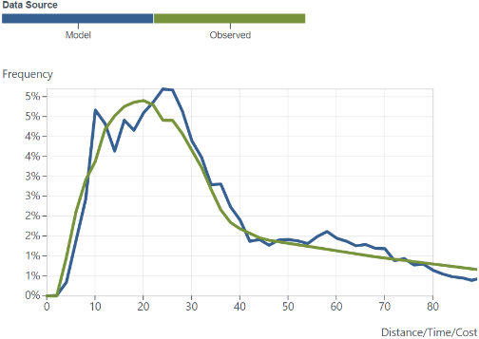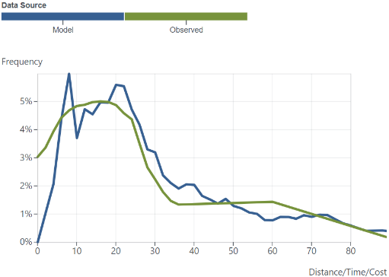

Figure . Trip Length Frequency (NHBNW, IX)

# Mode Choice

## Mode Share

The mode choice model was calibrated to observed mode shares from the 2012 Household Travel Survey and the 2019 Transit On-Board Survey. The results of this calibration effort are shown in Figure 2.1 through Figure 2.6. All mode shares were calibrated to within 5% of observed data.

### Mode Share Calibration Results (Daily, All Purposes)

Figure . Mode Share Calibration Results - Motorized / Non-Motorized (Daily, All Purposes)

Figure . Mode Share Calibration Results - Auto / Transit (Daily, All Purposes)

Figure . Mode Share Calibration Results - Drive Alone / Shared Ride (Daily, All Purposes)

Figure . Mode Share Calibration Results - Shared Ride 2 / Shared Ride 3 (Daily, All Purposes)

Figure . Mode Share Calibration Results - Transit Access Mode (Daily, All Purposes)

Figure . Mode Share Calibration Results - Transit Mode (Daily, All Purposes)

## Transit Trips and Boardings

Transit trips were validated to the 2019 Transit On-Board Survey and 2019 observed boarding data. To facilitate model calibration, transit trips, boardings, and transfers were validated by the model’s hierarchical mode. Boardings were also validated based on the mode where the boarding was actually observed. Transit validation results are shown in Figure 2.7.

Total transit trips and boardings were calibrated to within 5% of observed data (trips 1.6%, boardings -0.8%). Overall transfers were all within an acceptable range.

Transit trips and boardings by mode were calibrated to acceptable ranges for modes with significant ridership. Modes with low ridership were allowed to have a higher difference when compared to observed data if calibrating to increase base year accuracy resulted in too large alternative specific constants (i.e. over calibrating these modes). However, the following suggestions may help guide when using the model and interpreting model results:

* BRT validation results were low (between -6.7% and -12.6%). However, only one BRT route (UVX) was available in 2019 to calibrate this mode. Partly due to this, additional rounds of calibration to improve BRT resulted in large constants. This in turn would have the effect of making the base year validation better but overpredicting BRT in future forecasts, particularly as there is significantly more BRT in future plan phases. The decision was made to allow BRT to show lower than expected ridership in the earlier years of the model in favor of more reasonable BRT future-year forecasts.
* Core Route has a similar issue to BRT where only 1 Core Route (3500 S) was available in 2019 to calibrate this mode. Core Route had a much lower ridership in 2019 (roughly a tenth of the BRT ridership) which tends to show more extreme validation results. Core Route validation showed a similar pattern to BRT with lower trips and boardings (-14.4% and -14.0%, respectively) with the exception that the model was overpredicting total Core Route boardings (24.5%) resulting from slightly too many trips using this mode to transfer to a higher mode (LRT or CRT). Similar to BRT, the decision was made to not over calibrate this mode, in particular as there is also significantly more Core Route in future plan phases, in favor of more reasonable Core Route future-year forecasts.
* Express Bus trip and boarding validation results are higher than desired (8.5% and 11.6%, respectively). However, Express Bus ridership in 2019 is not significant and Express Bus service is expected to decrease in future plan phases. Note that the model underpredicts overall boardings (-17.2%) largely due to the observed data showing trips in the downtown area are transferring from other modes (e.g. CRT) to use Express Bus more as a local downtown circulator. The model does not capture this behavior.

**Trips by**

**Hierarchical Mode**

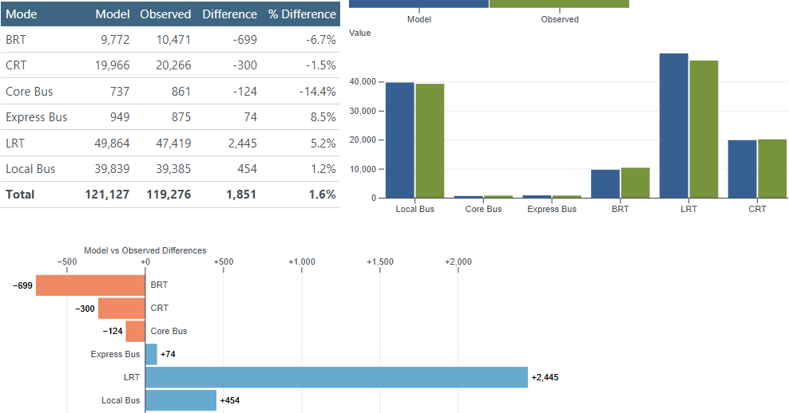

**Boardings by**

**Hierarchical Mode**

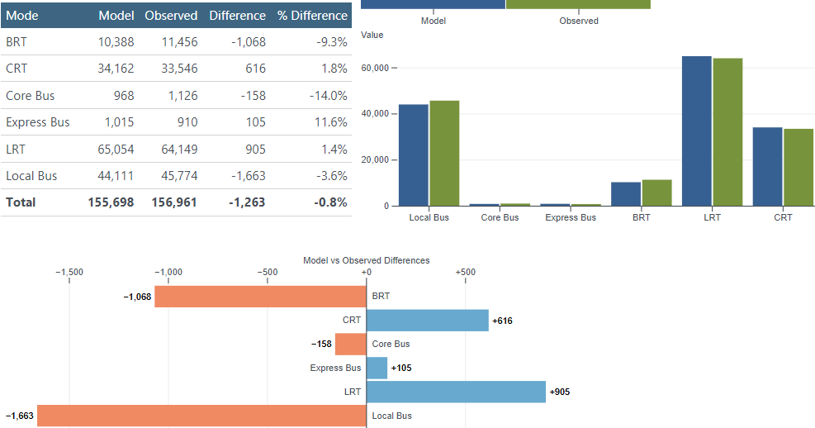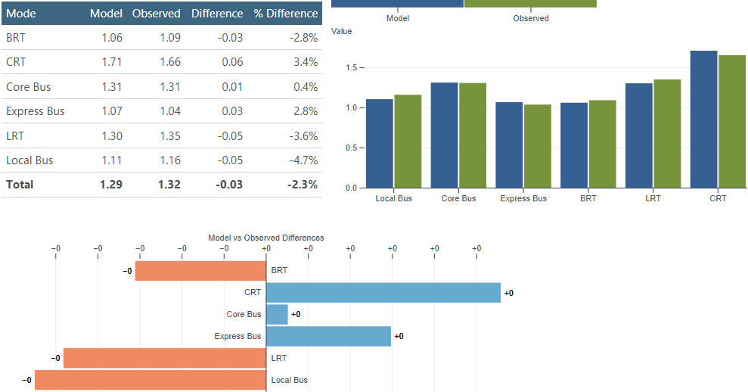

**Transfer Ratio by**

**Hierarchical Mode**

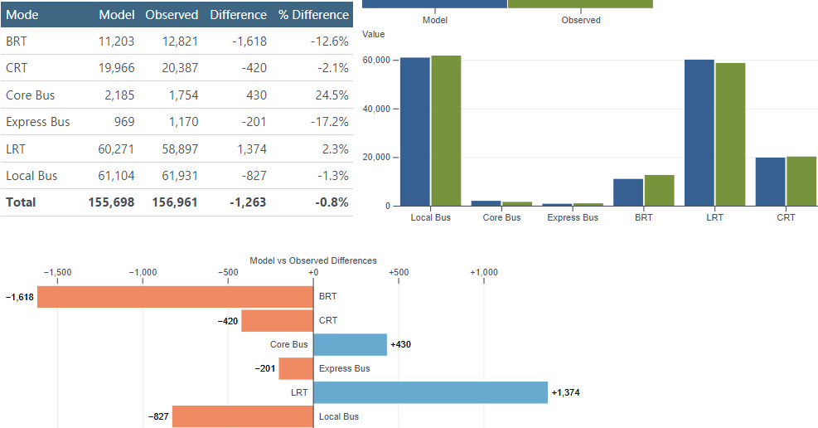

**Boardings by   
Observed Mode**

Figure . Trips and Boardings by Mode Surveyed - Model vs. Observed Comparison

# Highway Assignment

## Volumes

Model volumes and vehicle-miles travel (VMT) were validated against observed data. The observed data for 2019 volumes is taken from the Utah Department of Transportation (UDOT) [Average Annual Daily Traffic (AADT) History](https://drive.google.com/file/d/1rDXm0ObugGR1zXgWUuVbzWHNt-Xs1xru/view) and associated with their respective model segments. Observed VMT was calculated by multiplying the observed volume by the model segment distances.

Figure 3.1, Figure 3.2, and Figure 3.3 showmodel and observed values for the region at the all vehicle, medium truck, and heavy truck levels. The comparisons are shown in four different types of charts and tables:

* *Average Daily Volume by Roadway Class (2a)*: The daily volume is averaged across all segments within their respective geography and vehicle type.
* *Total VMT by Roadway Class (2b)*: For each segment, the daily volume is multiplied by segment distance and then summed across all segments within their respective geography and vehicle type.
* *Model vs Count Segment Volume (2c)*: This is a scatter plot of segment daily volume with the x-axis as the observed volume and the y-axis as the model volume. The gray line shows the location of where model and observed volumes are equal. The dashed blue line shows a least-squares linear regression. The further the blue line moved away from the gray line, the further the model is from observed.
* *Segment Percent Error (2d)*: This is a scatter plot showing the amount of error (percent difference) between the observed volume and the model volume. The observed volume is the x-axis and the percent error is the y-axis. The gray lines are a bounding box that shows the control target. As volume increases, it is expected that the percent error should decrease.

Figure . Model vs Observed Volume and VMT Comparison (Region, All Vehicles)

Figure . Model vs Observed Volume and VMT Comparison (Region, Medium (MD) Trucks)

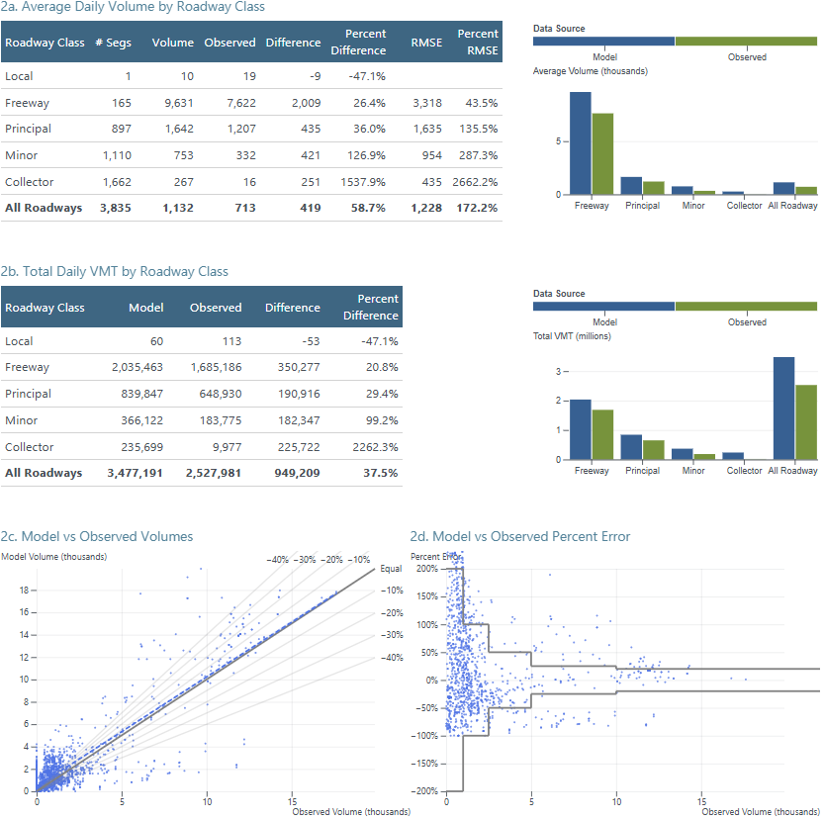

Figure . Model vs Observed Volume and VMT Comparison (Region, Heavy (HV) Trucks)

As shown in Figure 3.1, the volume and VMT of all vehicles at the region-wide level closely matches the validation targets. Volume for all roadways is only 1.7% higher than observed and VMT for all roadways is only 1.5% higher than observed.

As shown in Figure 3.2 and Figure 3.3, the model currently overpredicts Medium and Heavy trucks. A good amount of effort was spent attempting to bring model truck volumes closer to observed. However, due to truck data limitations and other model resource considerations, further calibration was stopped. Truck modeling remains a future priority for model improvement.

In addition to the charts, the maps in Figure 3.4 shows a comparison of segment level model vs observed volumes by vehicle types. Blue represents model lower than observed and red represents model volume higher than observed.

Figure . Segment-Level Model vs Observed Volume Comparison by Vehicle Type

Looking at the *All Vehicles* map, the model volumes are lower than observed for by more than 7,500 vehicles per day for the east side of I-215 and by more than 15,000 vehicles per day for I-15 through northern Utah County. Model volumes are higher than observed volumes by more than 15,000 vehicles for I-15 in southern Salt Lake County and for I-15 in Utah County between Springville and Spanish Fork. When looking at these areas by vehicle type, volumes for both *Medium Trucks* and *Heavy Trucks* are slightly greater than observed. Overall, the volume differences between model and observed are relatively minor.

The lower arterial model vs observed volumes of *Heavy Trucks* on 9000 South in Salt Lake County was further investigated. The *Heavy Truck* observed volume for this roadway seemed much higher than expected for this roadway. The lower volumes are likely due to the observed data and not anything in the model.

## Average Travel Time

The model’s average travel time was compared to observed data between (how many) various origin and destination locations throughout the model space. Observed travel times came from the Google API for various times throughout 2019. All observed data was collected on Tuesday through Thursday. Due to a data collection issue, observed average travel times were only available for the WFRC area. Model data came from the final network skims that report travel times between every TAZ by period.

The validation results for average travel time are shown in Figure 3.5 through Figure 3.8. Looking at Figure 3.8 and knowing that evening speeds are similar to freeflow, we can deduce that in general the model’s freeflow speeds are about 10% faster than observed. In addition, a pattern exists in Figure 3.5 through Figure 3.7 where shorter trips (under 20 minutes) have shorter travel times than observed and longer trips (30-60 minutes) have longer travel times than observed. This suggests that the volume-delay function (VDF) curves are slightly too aggressive on higher end facility types (freeways and arterials). Overall, while these charts show an acceptable range of error, improvements to freeflow speeds and to the VDF curves are adjustments we will consider making in future models.

Figure . Model vs Observed Times AM Period

Figure . Model vs Observed Times Midday Period

Figure . Model vs Observed Times PM Period

Figure . Model vs Observed Times Evening Period